**CHAPTER 1**

**INTRODUCTION**

**1.1 Introduction about the domain**

In these contemporary days, Cloud provides veteran services to all the real time industries with multi servers and assists bigger organization in managing their data and sharing the data. Data users at any end of the world can access the data without any hurdle. Loads and load of data are being shared across the globe with the help of Cloud environment and the services. Users can store and retrieve data from the cloud storage from anywhere at any time without knowing any information from which server and from which place the data is being shared. The cloud computing provides various benefits regarding costs savings, zero in-house server costs, and various administration costs. Cloud provides its users with at most reliability which even cannot be promised with the in-house infrastructure in various organizations.

Fig:1.1- Structure of Cloud Computing

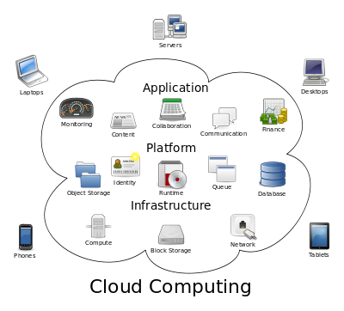

It is not the trend in these days that only grown up organization uses the cloud; instead, all the smaller, growing organization also started using cloud which provides them with promising benefits as the manageability is simple compared to their infrastructure management. The more important factor is the data in the cloud is trusted to be existing for a longer period. Despite the clouds many advantages, there was also the other side of the coin for the cloud having disadvantages like the limited control to the data owners as they cannot completely access the environment except for their data as it is secured and maintained by the service provider. The migration finds difficulty in migrating the services from one to another vendor is another alarming factor. Also, as the organizations are dependent on cloud data they face severe loss for any critical business data when there is an outage in the cloud. The major threat in cloud environment is the security threat as the a single service provider can hold the data of various organization if any one of them is a hacker there is a major possibility for a hacker to retrieve the other organization data, such exploits, and loopholes exist in the cloud environment Hence data security should be addressed with thicker layer to avoid security violation. Cryptography is the well-known technique for securing the data by encryption while sharing the information. There are various Cryptography techniques and are broadly categorized into two techniques namely symmetric encryption and asymmetric encryption technique. This paper proposes the algorithm RSA which is an asymmetric encryption technique is more suitable for cloud storage, as It assures major factors like confidentiality, authenticity, and integrity. In RSA cryptography, both the private and the public keys can encrypt a message; the opposite key from the one used to encrypt a message is used to decrypt it. This attribute is one reason why RSA has become the most widely used asymmetric algorithm: It provides a method of assuring the confidentiality, authenticity, integrity and non-reputability of electronic communications and data storage.

The RSA Algorithm uses the public and the private key generation technique for its cryptography. The prime numbers p and q which are large are created using the Rabin-Miller primality test algorithm. Then the modulus N is calculated for these two prime numbers by the product of P, and the generated number is then used for the public key and private key as a common factor among them. The length of the key is usually denoted in bits, and they are termed as Key length. Public key has the modulus N, also, exponent, e, is normally set at 65537 since it is a prime number that is not too large. The ‘e’ can be most common as this the public key which needs to be shared by all users. While the private key also possesses the modulus ‘n’, ‘d’ the private exponent and the calculation are done using an ExtendedEuclidean algorithm to generate the multiplicative inverse in regards to the totient of n.In Addition to RSA, there is another algorithm that gets the key from RSA as input and manipulates the another secure key possessing the combination of both the alphabet and numbers and this acts as the a private key to the user to decrypt the document.

**1.2 Scope of the Project**

This paper also proposes, Breadth Deepening Search algorithm to provide efficient search based on tree indexing. This algorithm combines only the advantages of Breadth and depth first search algorithms of Greedy. Always a search algorithm is said to be optimal if when it finds the best solution at the lowest cost. Hence, this algorithm is suggested based on this approach. This algorithm first performs a sequence of depth first search and goes till the end of depth then it removes the nodes that are generated in the first search then again repeat the depth search for second node and this process is continued until the goal is reached. As this algorithm expands all the nodes for the available depth, it is trusted that the solution is found.

**CHAPTER 2**

**LITERATURE SURVEY**

**2.1 Background**

Title 1: K. Ren, C.Wang, Q.Wang et al., “Security challenges for the public cloud,” IEEE Internet Computing, vol. 16, no. 1, pp. 69–73, 2012.

Cloud computing changes the behavior information technology (IT) is and managed, with, faster time-to-market, and the scale up the application on demand .With respect to Gartner, the hype grew exponentially during 2008 and continued as there is a quite bigger shift across cloud computing model .The shape of the cloud computing is emerging and developing both conceptually but in reality, it faces major issues with legality, security, and privacy issues. In this chapter,this paper describes various services and major deployment models of cloud computing and identify major challenges. In this paper, it has been discussed three critical challenges namely the security, regulatory and privacy issues in cloud computing. There are some solutions been proposed to handle these challenges along with a gist of presentation on the future trends in cloud computing deployment.

Title 2: B. Wang, S. Yu, W. Lou, and Y. T. Hou, “Privacy-preserving multi-keyword fuzzy search over encrypted data in the cloud,” in IEEE INFOCOM, 2014.

This paper proposes the enabling of keyword search over encrypted data which is shown as a desirable technique for effective usage of encrypted data that are outsourced to the cloud. There are many existing solutions that provide multi-keyword exact search that does not have the capability to recognize keyword spelling error and there is also feature for a single keyword fuzzy search that endures typo errors to a certain level. There were many related fuzzy search schemes available which trust the building of an index that mostly give coverage to possible keyword misspelling, that leads to significantly greater index file size and the benefits of higher search complexity. In this paper, there is a proposal of novel multi-keyword fuzzy search by manipulating the sensitive hashing technique. The proposed scheme in this paper achieves matching of fuzzy search through algorithmic design instead of expanding the index file. It also disregards the necessity of a predefined dictionary and meritoriously supports multiple keyword fuzzy search without swelling the index or search complexity. There are much wide analysis and experiments on real-world data to show that our proposed scheme is secure, efficient and accurate. To the best of our knowledge, this is considered to be the first work that accomplishes multi-keyword fuzzy search over the encrypted cloud data.

Title 3: C. Wang, N. Cao, K. Ren, and W. Lou, “Enabling secure and efficient ranked keyword search over outsourced cloud data,” Parallel and Distributed Systems, IEEE Transactions on, vol. 23, no. 8, pp. 1467–1479, 2012.

Cloud computing thriftily enables the model of data service subcontracting. To protect data privacy, profound cloud data has to be encrypted before outsourcing to the public commercial cloud that styles effective data utilization provision a very challenging task. Although outdated searchable encryption techniques allow users to perform securely search over encrypted data by using keywords, however, they support only Boolean search and they are not yet necessary to meet the current data utilization demand that is fundamentally demanded by an outsized number of users and a massive amount of data files in the cloud. In this paper, we propose to define and explain the delinquent of secure ranked keyword search over encrypted cloud data. Graded search greatly augments system usability by enabling search result bearing ranking instead of sending identical results, and also further ensures the trusts on file recovery accuracy. Precisely, we explore the arithmetical measure approach, i.e. relevance score, from material retrieval to build a secure searchable index, and advance a one-to-many and the order-preserving mapping technique to appropriately protect those searching score information. The occasioning design is able to facilitate effectual server-side ranking without trailing keyword privacy. The thorough analysis shows that our proposed result enjoys “as-strong-as-possible” security pledge compared to previously searchable encryption schemes although correctly realizing the goal of ranked keyword search. There were extensive experimental results demonstrate the efficiency of the proposed solution.

Title 4: B. Gu and V. S. Sheng, “Feasibility and finite convergence analysis for accurate on-line -support vector learning,” IEEE Transactions on Neural Networks and Learning Systems, vol. 24, no. 8, pp. 1304–1315, 2013.

There are many algorithms for self-governing component analysis (ICA) and blind source separation (BSS) that can be considered for precise instances of a measure based on the sum of two terms: C(Y), which couriers the decorrelation of the works and G(Y), which measures their non-Gaussianity. In this framework, the widespread FastICA algorithm can be regarded as a practice that keeps C(Y) ¼ 0 by first implementing the pallor of Y. Because of this limitation, the average version of FastICA services the sample-fourth moment as G(Y), in its place of the sample-fourth cumulant. This work studies some of the valuation errors introduced by the use of fixed date sets in such a higher-order numbers (HOS) distinction and links FastICA with an alternative kind based on the sample-fourth cumulant, which is shown for different prospect circulations having a lower adjustment in the summary error in the case in which no bleaching is performed, e.g. when orthonormal mingling of sources is present.

Title 5: S. Kamara and K. Lauter, “Cryptographic cloud storage,” in Financial Cryptography and Data Security. Springer, 2010, pp. 136–149.

There are developments in networking technology and a surge in the need for computing possessions have provoked many organizations to contract out their storage and totaling needs. This new economic and totaling model is commonly referred to as cloud computing and embraces various types of services such as infrastructure as a service (IaaS), where a customer kinds use of a service provider’s computing, storage or make contacts infrastructure; platform as a service (PaaS), where a customer forces the provider’s possessions to run custom applications; and to conclude software as a service (SaaS), where consumers use software that is run on the worker’s infrastructure. Cloud organizations can be roughly considered as whichever private or public. In a private cloud, the structure is managed and recalled by the patron and sited on-premise (i.e., in the customer’s region of control). In certain, this means that admittance to customer data is under its governor and is only arranged to parties it hopes. In a public cloud, the set-up is owned and succeeded by a cloud service provider and is placed off-premise (i.e., in the cloud service provider’s region of control). This means that patron data is outside its organizer and could potentially be approved to untrusted parties. Loading services based on communal clouds such as Microsoft’s Azure storage service and Amazon’s S3 provide customers with walkable and dynamic loading. By moving their data to the cloud clients can avoid the costs of building and continue a private storage set-up, opt-in its place to pay a service worker as a function of its needs. For most customers, this provides some benefits including availability (i.e., being able to admission data from everyplace) and reliability (i.e., not taking to worry about gridlocks) at a fairly low cost.

**2.2 Limitations & Drawbacks**

There are various limitation in cloud concerning security and many drawbacks is seen in the above analysis regarding violations of security.This triggered to take action on security threats at all levels however public cloud environment cannot assure security at any level.

**CHAPTER 3**

**PROBLEM DEFINITION**

**Objective:**

Cloud storage is a vast model with a mixed network of data users and owners and data are stored in a pool and it is the responsibility of cloud providers to maintain the data .The Search for any data is done by the data users across the globe and there are various data being hosted in the cloud for any service provider. The Search from the user based on the keywords needs to be secured and the turnaround time should be compensative for the user. As there are load and loads of data being hold up in the cloud the data needs to properly arrange in an index tree structure to perform an efficient search. The search results also would require producing ranked results based on the view of a page. There is enough research happening every day to eradicate security concerns in cloud among the data sharing as there are millions of cloud users and data owners who want their data to be presented in the cloud for the users to search and access the data. Here are some of the challenges listed about the search and security challenges in cloud

**Problem Statement:**

* Searchable encryption schemes are there in the market but still security is a big concern in sharing the data
* Sometimes there is no efficient information retrieval in the cloud
* There are also possibilities for immaterial information being shown up to the user.
* Data owners have challenge in adding and eradicating of data in cloud as the data needs refresh every time
* Key management is very critical as there are many challenges for hacking
* Some CSPs do not store encrypted data
* CSPs can access the data without data owners awareness which is security violation

**Existing System**

In this project, we propose a secure tree-based search scheme over the encrypted cloud data, which supports keyword ranked search and dynamic operation on the document collection. The proposed search scheme can flexibly achieve sub-linear search time and deal with the deletion and insertion of documents. The basic dynamic multi-keyword ranked search (BDMRS) scheme in the known ciphertext model the enhanced dynamic multi-keyword ranked search (EDMRS) scheme in the known background model the secure kNN algorithm is utilized to encrypt the index and query vectors and meanwhile ensuring accurate relevance score calculation between encrypted index and query vectors.

**Proposed System:**

In this paper, we propose an efficient search over the encrypted cloud data by using Breadth Deepening Search algorithm and the encryption is best done by the enhanced RSA algorithm. Also, when there is an observation of any dishonest activity from the data user then the access for the user is revoked and needs data owner permission again to resume search

**Advantages Of Proposed System:**

We design a searchable encryption scheme that supports both the accurate multi-keyword ranked search and flexible dynamic operation on document collection. Due to the special structure of our tree-based index, the search complexity of the proposed scheme is fundamentally kept to logarithmic and this gives better performance. The proposed scheme can achieve higher search efficiency by executing our “Breadth Deepening Search algorithm” by retrieving the exact and most relevant search. Hacker’s unauthorized access are noticed and their access is revoked for security concerns.

**CHAPTER 4**

**METHODOLOGIES**

**Architecture**

The system architecture is a theoretical model that outlines the structure, performance, and more assessments of a system. A planning description is a formal portrayal and depiction of a system, organized in a system that supports cerebral about the structures and activities of the system

Fig : 4.1 - Architecture Diagram

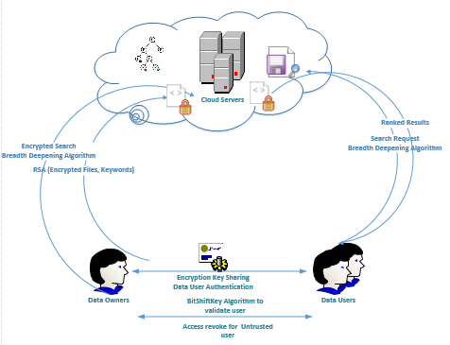

**System Design**

**UML Diagrams**

UML stances for Unified Modeling Language. UML is an even general-purpose showing oral in the field of the object-oriented software corporate. The standard is succeeded and was created by the Object Management Group.

The goal is for UML to become a mutual language for generating models of object-oriented computer software. In its recent form, UML is contained of two major apparatuses: a Meta-model and a system. In the future, some form of process or method may also be added to; or linked with, UML.

The Unified Modeling Language is a normal language for agreeing, Conception, Making and verifying the objects of a software system, as well as for occupational modeling and other non-software schemes.

The UML represents an assortment of best business practices that have proven successful in the showing off large and multipart systems.

The UML is an identical important part of evolving objects oriented software and the software improvement process. The UML uses mostly graphical ciphers to rapid the plan of software projects.

**Goals:**

The Crucial goals in the idea of the UML are as follows:

1. Provide users a ready-to-use, forthcoming visual displaying Language so that they can develop and talk substantial models.
2. Provide extensibility and knowledge instruments to extend the core concepts.
3. Be self-governing of particular programming dialects and change process.
4. Provide a proper basis for understanding the exhibiting language.
5. Inspire the growth of OO tools market.
6. Support sophisticated level advanced concepts such as relationships, backgrounds, patterns, and constituents.
7. Participate best practices.

**Use Case Diagram:**

A use case diagram is a sort of behavior diagram defined by and created from a Use-case analysis. Its resolution is to present a graphical overview of the functionality provided by an arrangement in terms of artists, their goals (represented as use cases), and any cravings between those use cases. The main purpose of a use case diagram is to show what system jobs are performed by which actor. Roles of the artists in the system can be shown.

Fig:4.2- Use Case Diagram



**Class Diagram:**

In the aspect of software engineering, a class diagram in the is a type of inert assembly figure that defines the building of a system by viewing the scheme's classes, their qualities, actions (or methods), and the dealings amid the classes. It explains which class contains information

Fig:4.3- Class Diagram



**Sequence Diagram:**

A sequence diagram is a type of interaction diagram that shows how courses function with one extra and in what order. It is a concept of a Message Sequence Chart. Sequence diagrams are occasionally called event diagrams, event situations, and timing diagrams.

Fig:4.4- Sequence Diagram



**Collaboration Diagram**

A collaboration diagram is a type of visual presentation that shows how various software objects interact with each other within an overall IT architecture and how users can benefit from this collaboration. A collaboration diagram often comes in the form of a visual chart that resembles a flow chart.

Fig:4.5**-** CollaborationDiagram



**Activity Diagram:**

Activity diagrams are graphical symbols of workflows of stepwise happenings and travels with support for special, repetition, and concurrency. In the Unified Modeling Language, activity diagrams can be used to define the occupational and operative step-by-step workflows of workings in a system. An activity diagram shows the complete flow of control.

Fig:4.6- ActivityDiagram



**Data flow diagram**

A data flow diagram (DFD) is a depiction of the "movement" of data concluded an info system, showing its process features. A DFD is often used as an opening step to creation a summary of the system, which can later be elaborated.

Fig:4.7- Data FlowDiagram

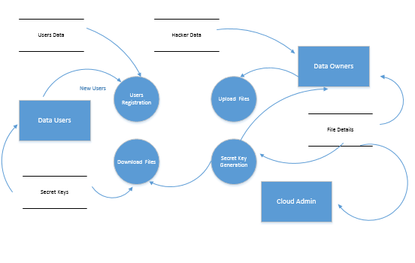

**Algorithm**

**Greedy algorithms:**

(A) Brand conclusion incrementally in minor steps without backtracking

(B) Decision at each step is based on refining local or current state in a bigoted fashion deprived

of disbursing attention to the global state

(C) Verdicts often based on some secure and humble urgency rules

**Breadth Deepening Search (BDS) Algorithm**

In the proposed system, the data owner uploads the files to the cloud using RSA encryption algorithm. The cloud holds the encrypted data ensuring the data is secured in the cloud and even the cloud service provider cannot access the data. The data owner tries to do a search in the cloud data and this is achieved by the Breadth Deepening Search algorithm which supports the multi-keyword search, fuzzy search across the documents in the cloud to facilitate the user in retrieving the accurate as well as most relevant document. The user can also do a rank based search and this is implemented using the page hit algorithm that displays the highest hit in the descending order.

The breadth deepening search algorithm follows the procedure as,

procedure IDDFS(RootNode)

for depth from 0 to ∞

NodeExists ← DLS(RootNode,depth)

if NodeExists ≠ null

return NodeExists

procedure DLS(SearchNode, depth)

if depth = 0 and SearchNode, is a goal

return SearchNode

else if depth > 0

for each child of SearchNode

NodeExists ← DLS(child, depth−1)

if NodeExists ≠ null

return NodeExists

return null

Fig:4.8- Node Calculation

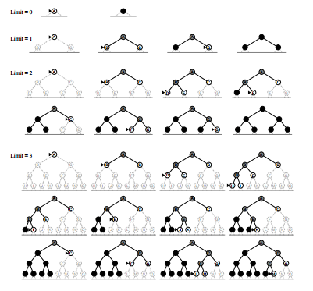

time complexity (generated nodes):

Iterative deepening DFS 🡺 (d + 1) + db + (d − 1)b 2 + · · · + 2b d−1 + 1b d

Theorem (time complexity of iterative deepening DFS) Let b be the dividing factor and d be the nominal solution dimension of the given public space. Let b ≥ 2.

Then the time complexity of iterative deepening DFS is

(d + 1) + db + (d − 1)b 2 + (d − 2)b 3 + · · · + 1b d = O(b d ) and the memory retention complexity is O(bd)

**Advantages:**

Tree search is acceptable (no identical elimination necessary)

All exploit costs are identical

The solution depth is unknown.

4.1 Iterative deepening search properties

|  |  |
| --- | --- |
| **Criterion** | **Iterative deepening Algorithm** |
| Complete? | Yes |
| Optimal? | Yes |
| time | O(b^d) |
| space | O(bd) |

The search displays the lists of documents based on the keywords and then user requests the data owner for the document download. Then the data owner generates the secret key using **BitShift Key(BSK) algorithm** and sends the same to the user.

**Pseudocode for BSK**

1. Generate random number N

2. Take any two prime numbers p, q

3. Calculate Modulus M for N, p, q

4. Declare Array of 32 characters to the variable A

4. Assign 32-bit constant value to the variable B

5. Iterate the below steps 10 times

• Perform BIT AND operation for M and B then do byte conversion and store in E

• Perform 3-bit right shift for B and this gives the new value for E

• Identify position of character from A using the value of E and concatenate the characters for each iteration and that will be the secret key

The user should first authenticate himself using the secret key then after authentication the user can download the document using the RSA private key

**RSA:** Rivest Shamir Adleman Algorithm

Pseudocode for RSA

• Choose p and q

• Calculate n = p * q

• Compute φ(n) = (p - 1) * (q - 1)

• Choose e such that 1 < e < φ (n) and e and n are coprime.

• Compute value for d such that (d * e) % φ(n) = 1

• Public key is (e, n)

• Private key is (d, n)

The user when he tries to authenticate with the incorrect secret key then he is detected as a hacker by the Data owner and the user access is withdrawn. Hence, there is advantage of detecting the hacker before he tries to download the file

### Encryption

The ciphertext C is found by the equation 'C = Me mod n' where M is the original message.

### Decryption

The message M can be found from the ciphertext C by the equation 'M = Cd mod n'.

**Module Description**

A module is a portion of a program. Programs are unruffled of one or more individually developed modules that are not shared until the program is linked. A single module can contain one or several sequences. Our project modules are given below:

* **Cloud Server**
* **Cloud Repository**
* **Data User**
* **Data Owner**

**Cloud Server:**

Cloud server stores the encrypted file collection *C* and the encrypted searchable tree index *I* for data owner. While getting the trapdoor *TD* from the data user, the cloud server performs a search over the index tree *I*, and finally proceeds the equivalent collection of top-*k* graded encrypted documents. Besides, upon getting the removal of a document from the data owner, the server needs to delete and update the index *I* and document collection *C* according to the expected information.

Fig: 4.9- Cloud Server

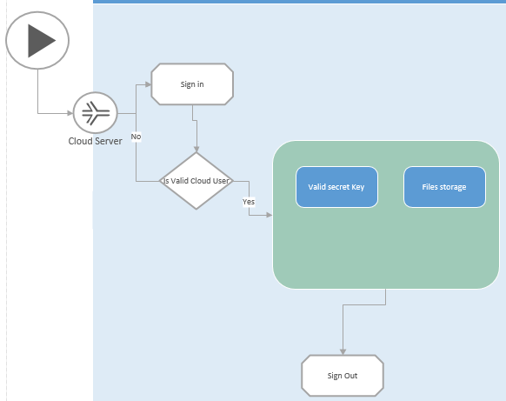

**Cloud Repository:**

The cloud repository shows the lists of files from the data owner. The hacker information is also stored in the repository explicitly displaying the hacker’s information for the username, filename, secret keys tried, keywords tried, and the option for the user to revoke hacker. Once the hacker access is revoked the user is deleted from the database and next time the user cannot access the data owner information.The cloud repository possesses details about the user,the particulars like user id,name,Mobile number, email id, city and the registered data is being displayed in the module

Fig: 4.10 - Cloud Repository

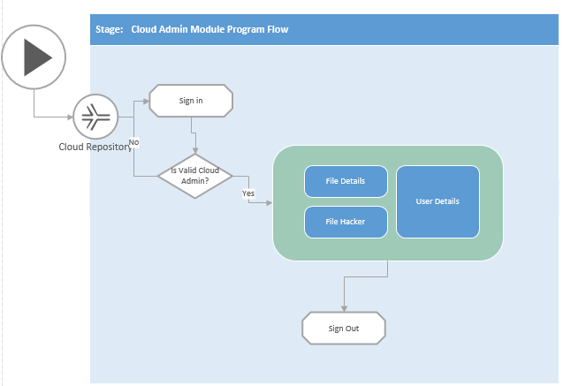

**Data User:**

Cloud users are authorized ones to access the documents of the data owner. They get authenticated by the data owners and during a search with *t* query keywords, the data user tries to search the documents for the most relevant search also with the keywords and try to queue the request to the data owner to download the file using file request module. The Data user receives a secret key from the data owner and using the secret key, the authorized user can create a trapdoor *TD* rendering to search control mechanisms to fetch *k* encrypted documents from the cloud server. The data user also has the ability to search based on grade for the fittest files the features of the list are ranked in descending order affording to the *RScore*, and will be restructured timely during the search process.

Fig: 4.11- Data User

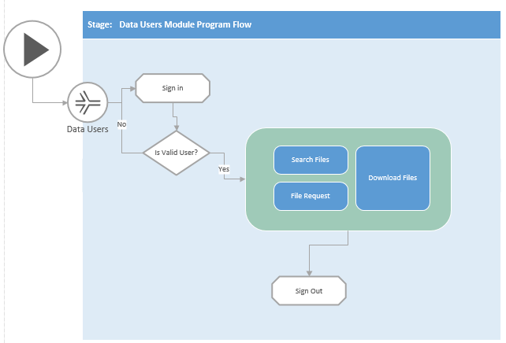

**Data Owner:**

Data owner has a group of forms *F* =*{f*1*; f*2*; fn}* that he wants to outsource to the cloud server in encrypted form while still keeping the skill to search on them for active operation. Afterward, the data owner subcontracts the encrypted collection *C* and the protected index *I* to the cloud server and securely distributes the key data of trapdoor generation for document decryption to the approved data users by sending the secret key via email. The data owner allocates keywords to every file. Data Owner views the file request from the users with all the details comprising the file name, user Id, and the date requested.Data owner gives a key to every file casually which is generated by secret key generation protocol which generates the key uniquely and sends the private key to the user by selecting the user.

Fig: 4.12 - Data Owner

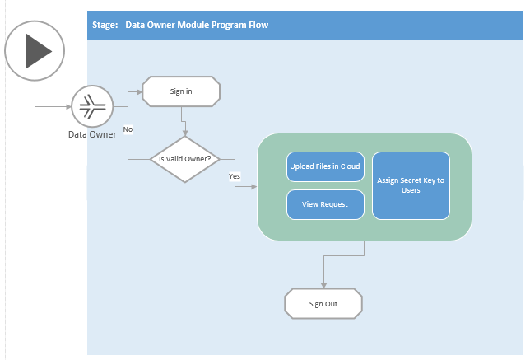

**CHAPTER 5**

**IMPLEMENTATION**

Implementation is the period of the project when the hypothetical design is turned out into a working system. Thus, it can be measured to be the most critical stage in achieving an effective new system and in giving the user, assurance that the new system will work and be effective. The execution stage involves careful scheduling, the inquiry of the existing system and it’s limitations on implementation, designing of methods to achieve exchange and evaluation of changeover methods.

**Software Tools**

The purpose of system requirement specification is to produce the requirement analysis of the task and also to launch complete information about the Prerequisite, comportment and other constraints such as practical performance and so on. The goal of system requirement specification is to completely specify the technical necessities for the product in a summarizing and unambiguous manner.

Hardware Requirements:

System : Pentium IV 2.4 GHz.

Hard Disk : 40 GB.

Floppy Drive : 1.44 Mb.

Monitor : 15 VGA Colour.

Mouse : Sony.

Ram : 512 Mb.

Software Requirements:

Operating System : Windows 7/8

Front End : Visual Studio 2010

Back End : SQL Server 2005

**System Input and System Output**

**Input Design**

The input design is the relation between the data system and the user. It encompasses the developing condition and measures for data preparation and those steps are necessary to put business data into a usable form for dispensation can be achieved by reviewing the computer to read data from a written or printed document or it can occur by having people inputting the data directly into the system. The plan of input focuses on regulatory the amount of input required, regulatory the errors, avoiding delay, avoiding extra steps and keeping the process simple. The input is calculated in such a way so that it offers security and ease of use with retentive the privacy. Input Design measured the following possessions

* What data should be agreed as input?
* How should the data be organized or coded?
* The dialog to guide the functioning personnel in providing input.
* Methods for preparing input proofs and steps to follow when error occur.

**Objectives**

1. Input Design is the process of adapting a user-oriented report of the input into a computer-based system. This design is imperative to avoid errors in the data input process and show the correct route to the management for getting correct information from the electronic system.

2. It is achieved by making user-friendly screens for the data entry to handle a large capacity of data. The goal of conniving input is to make data entry relaxed and to be free from errors. The data entry screen is calculated in such a way that all the data operates can be performed. It also delivers record inspecting facilities.

3. When the data is passed into the system, it will check for its rationality. Data can be entered with the help of screens. Appropriate messages are provided as when needed so that the user will not be in maize of prompt. Thus, the fair of input design is to create an input layout that is easy to follow

**Implementation:**

In this project, the system input consists feeding the information for User Registration, Admin login, and the cloud repository login.

The files are feed from the data owner as input to store in the cloud.

The file search is done in terms of entering the file name, keyword and secret key is entered into the system to download the document.

**Output Design**

A quality production is considered as one, which meets the necessities of the end user and presents the data clearly. In any system results of dispensation are communicated to the users and to another system through outputs. In output design, it is resolute how the information is to be displaced for direct need and also the hard copy output. It is the most important and direct source data to the user. Efficient and academic output design improves the system’s connection to help user decision-making.

1. Manipulative computer output should ensue in an organized, well supposed out manner; the accurate output must be established while safeguarding that each output element is designed so that people will find the system can use easily and efficiently. When analysis designs computer output, they should recognize the precise output that is needed to meet the requirements.

2. Select approaches for presenting information.

3. Generate document, report, or additional formats that contain information produced by the system.

The output form of an evidence system should complete one or more of the following objectives.

* Take information about past activities, current status or projections of the
* Future.
* Signal vital events, opportunities, problems, or warnings.
* Trigger an action.
* Confirm an action.

**Implementation:**

In this project, System output displays as in table to provide a view to the Data owner about the file requests details, assigning the key to the user. The cloud repository displays the lists of files, file hacker details, and the user details. The user will be shown with the lists of files after every search is done.The User will also be displayed with the ranking score for the number of times the file is accessed.

**CHAPTER 6**

**RESULTS AND ANALYSIS BASED ON THE OBJECTIVE**

The Analysis is done for the suggested greedy depth-first search algorithm in the base paper against the implemented Breadth Deepening Search algorithm in this project

**Greedy Depth-first Search Algorithm(DFS) Analysis**

Tab:6.1- Greedy Depth First analysis in search

|  |  |  |
| --- | --- | --- |
| **Algorithm** | **Time of search (ms)** | **# of documents in the collection** |
| Greedy Depth First | 2.0222 | 10 |
| Greedy Depth First | 3.444 | 60 |
| Greedy Depth First | 4.533 | 50 |
| Greedy Depth First | 3.343 | 20 |
| Greedy Depth First | 5.45 | 90 |
| Greedy Depth First | 3.5 | 30 |

Fig: 6.1 – Greedy DFS Analysis

**Breadth Deepening Search(BDS) algorithm**

Tab: 6.2- Breadth Deepening Search algorithm in search

|  |  |  |
| --- | --- | --- |
| **Algorithm** | **Time of search (ms)** | **# of documents in the collection** |
| Breadth Deeping Search | 1.333 | 10 |
| Breadth Deeping Search | 2.232 | 60 |
| Breadth Deeping Search | 3.224 | 50 |
| Breadth Deeping Search | 2.66 | 20 |
| Breadth Deeping Search | 4.33 | 90 |
| Breadth Deeping Search | 2.8 | 30 |

Fig: 6.2 – Breadth deepening algorithm Analysis

**Screen Shot**

**Home Page:**

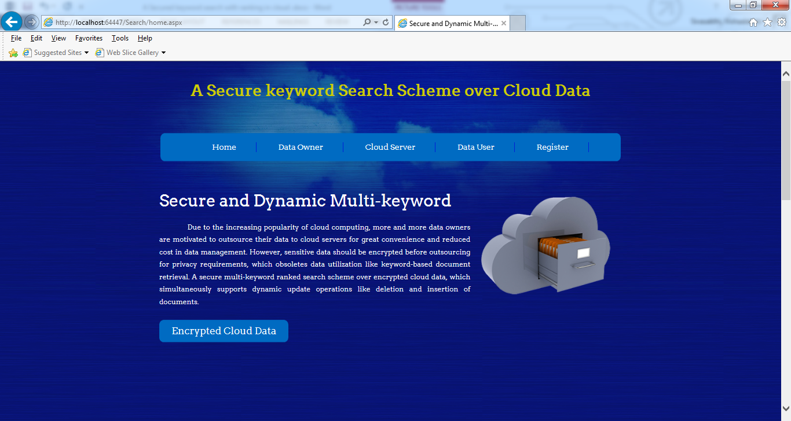

**User Registration:**

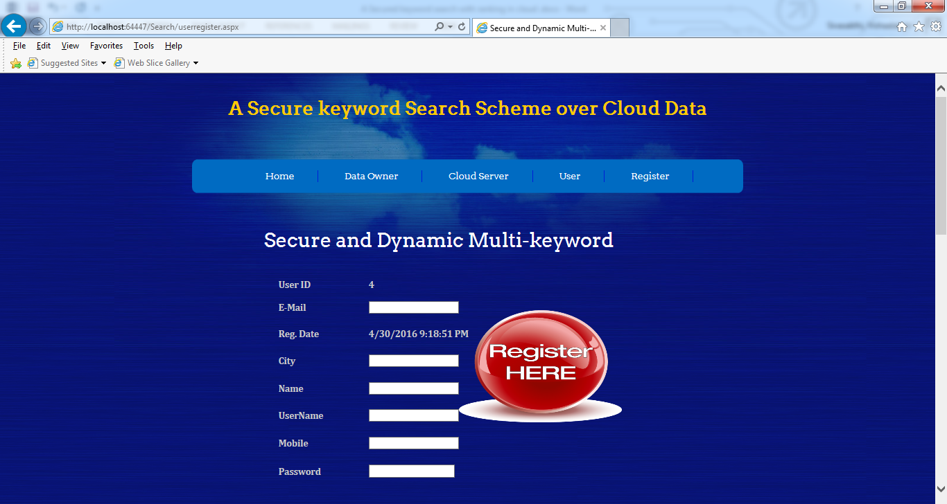

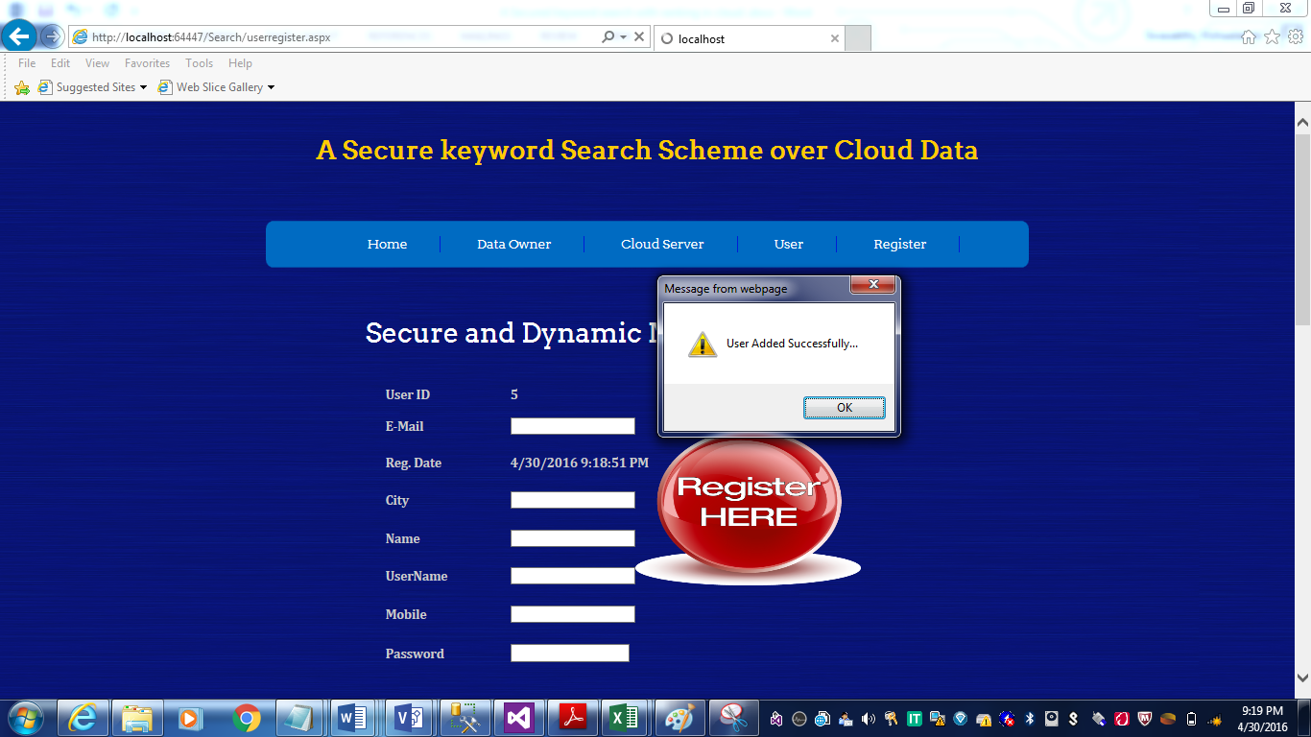

**User Login:**

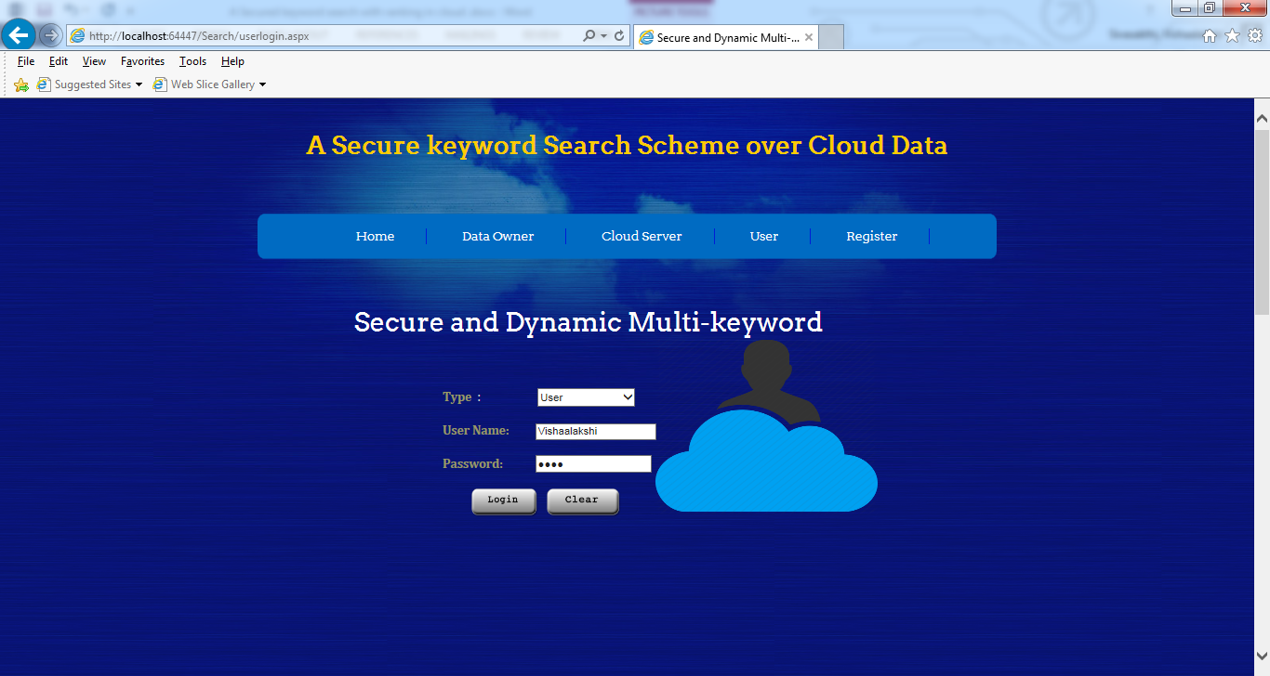

**User Home Page:**

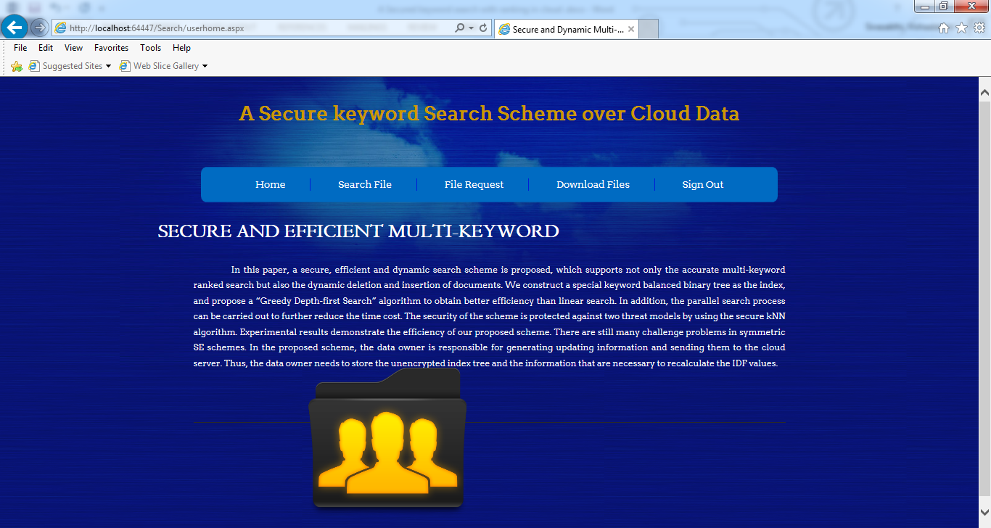

**Search File – File Search:**

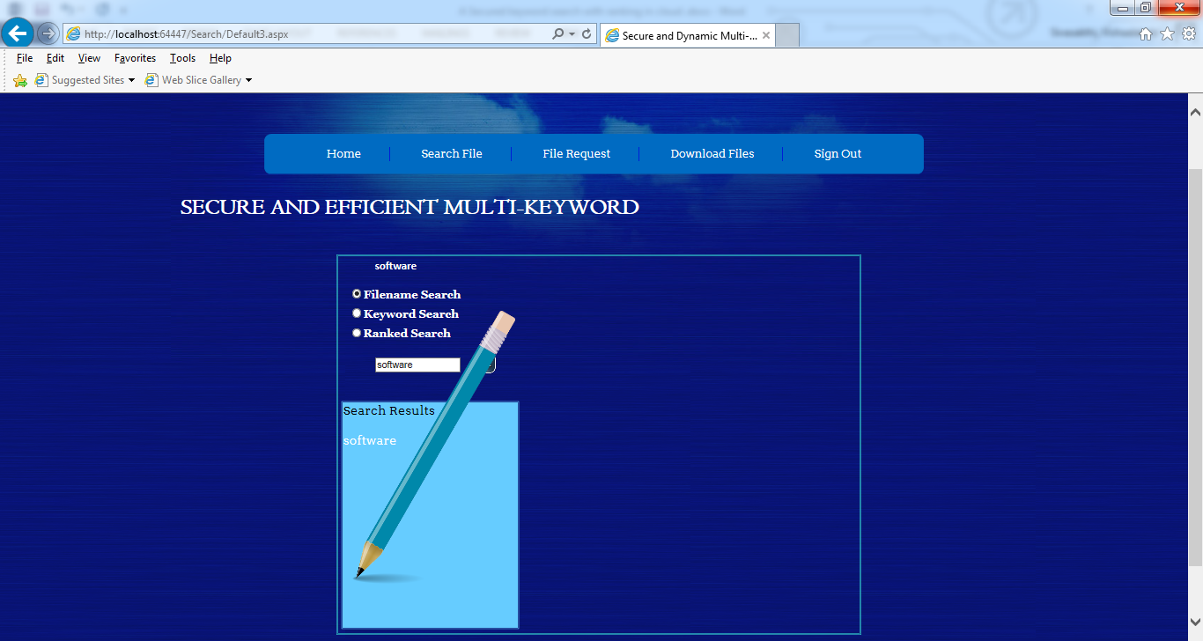

**Search Files – Keyword Search**

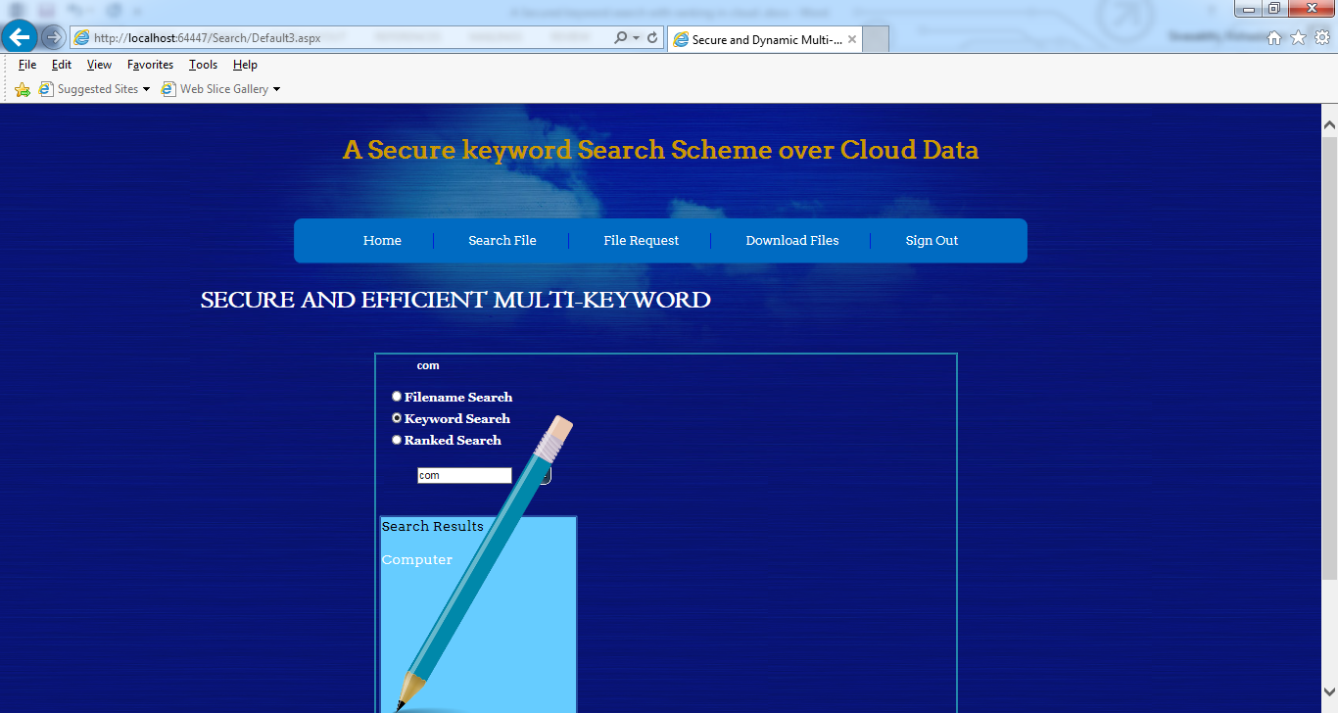

**Search File – Ranked Search** 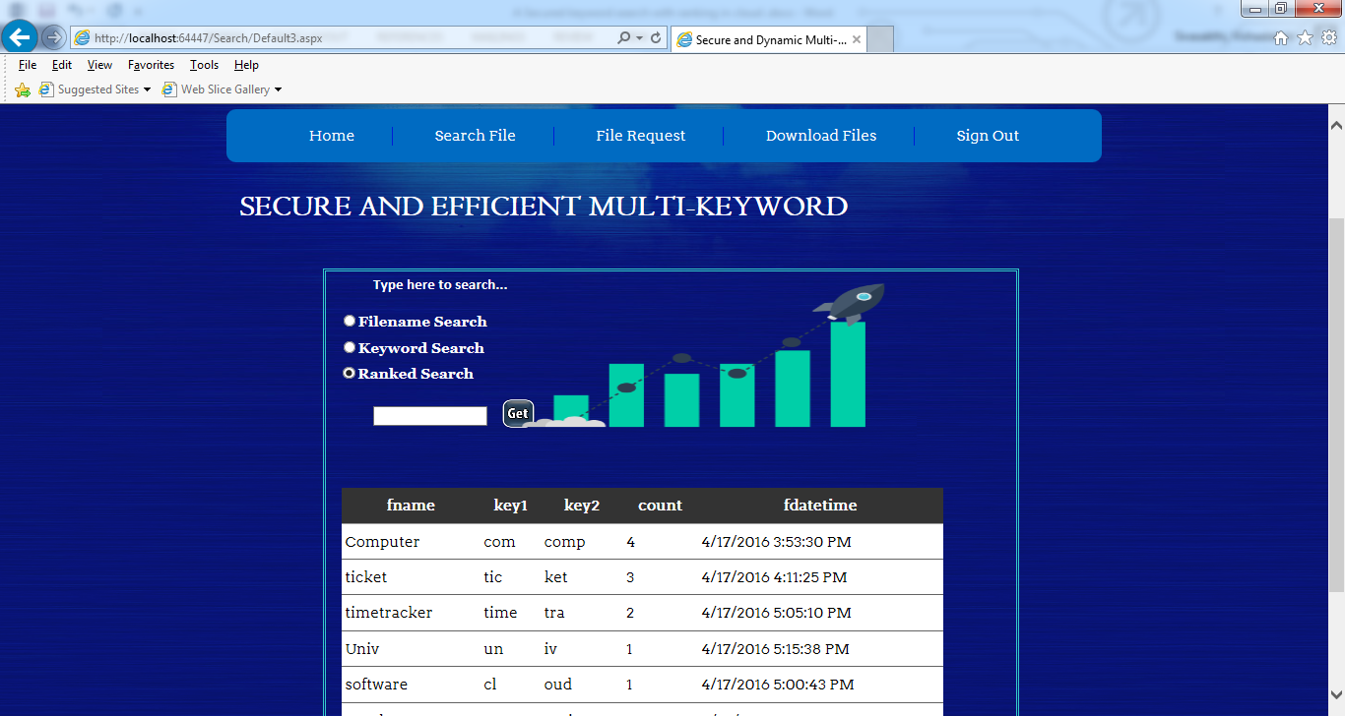

**File Request:**

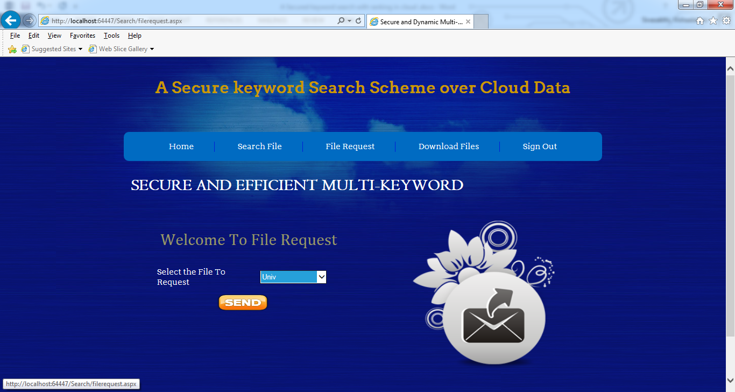

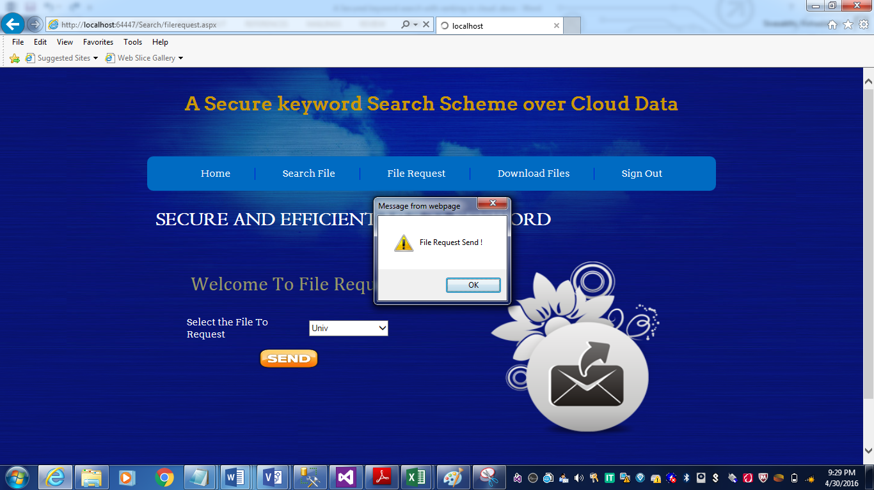

**Download Files:**

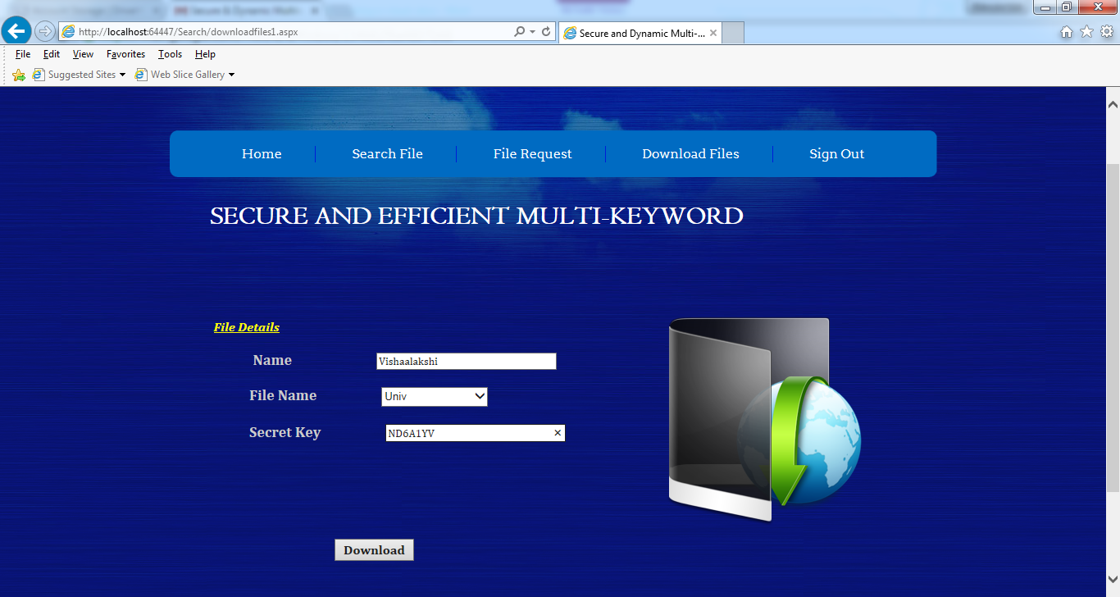

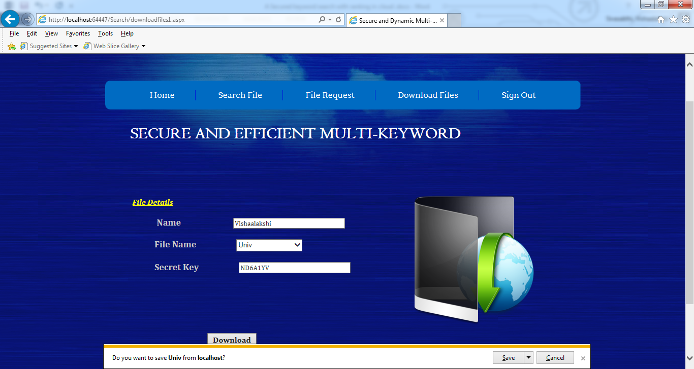

**Cloud Login:**

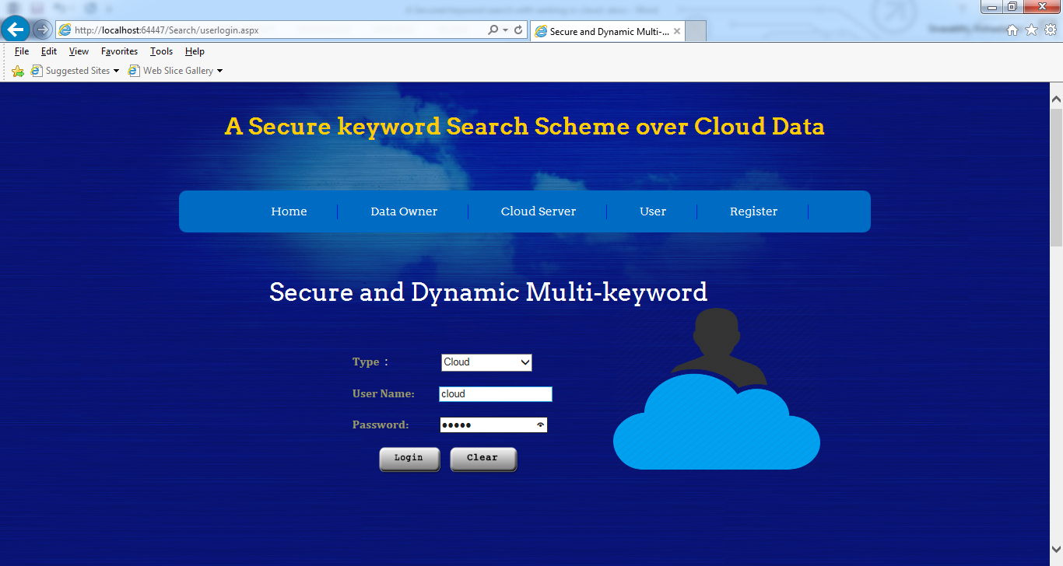

**File Details:**

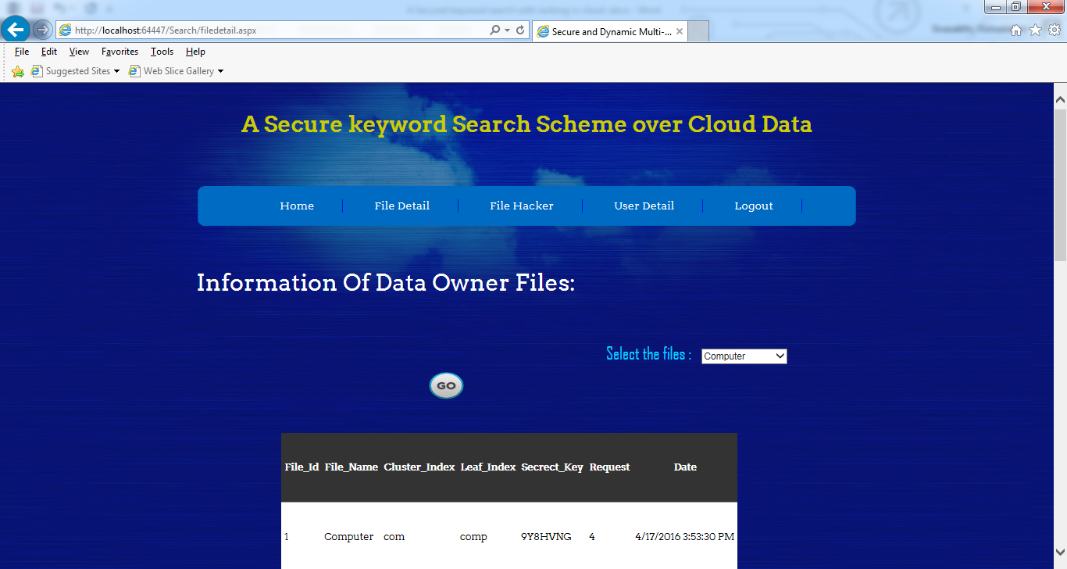

**Hacker Details:**

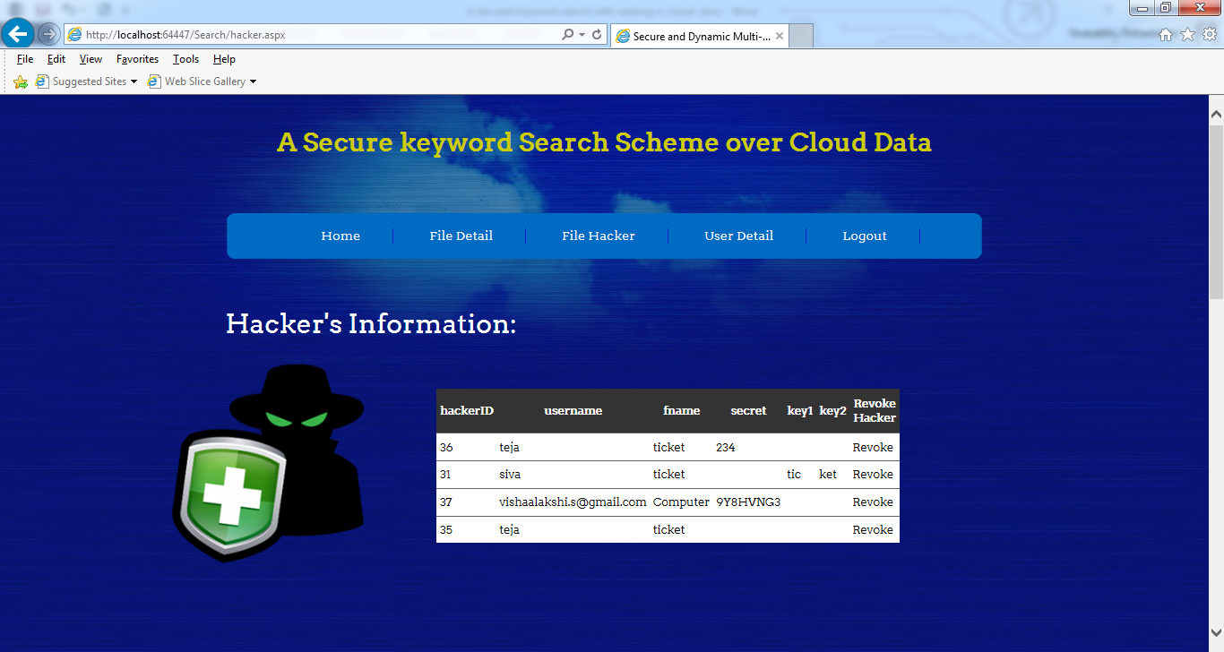

**User Details:**

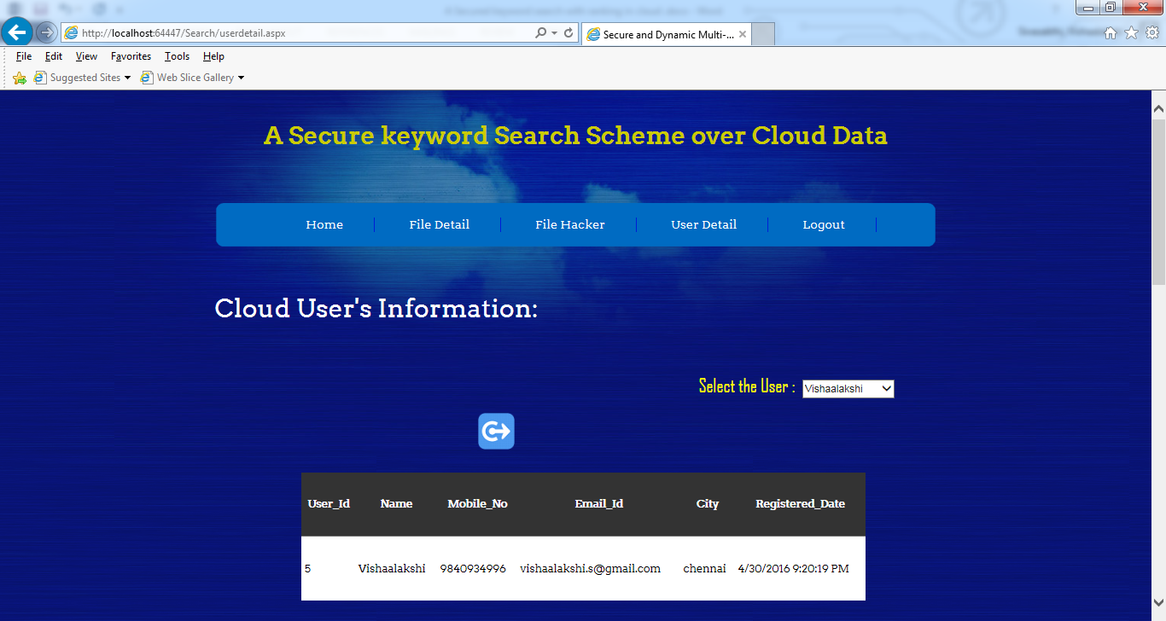

**Owner Login:**

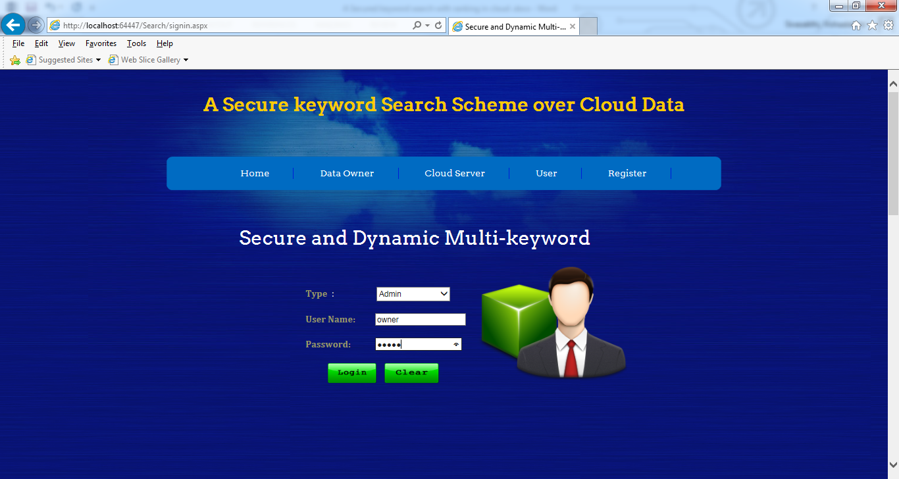

**Upload File:**

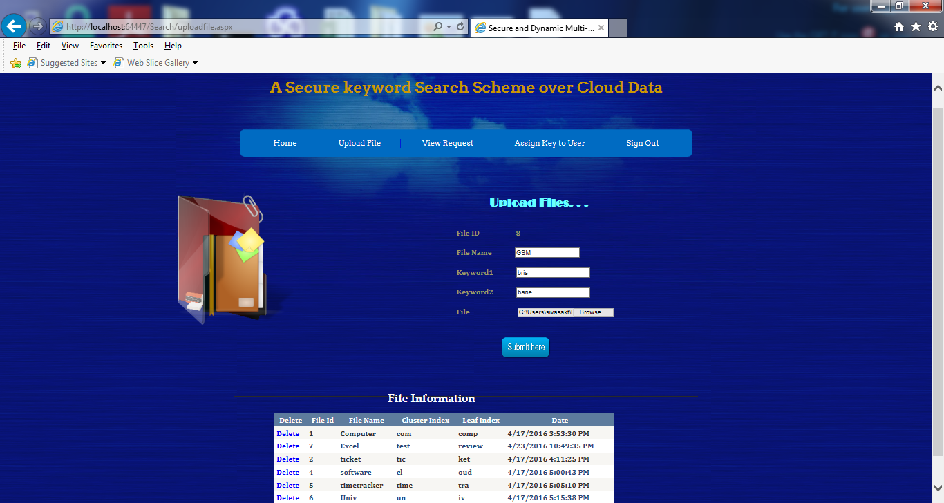

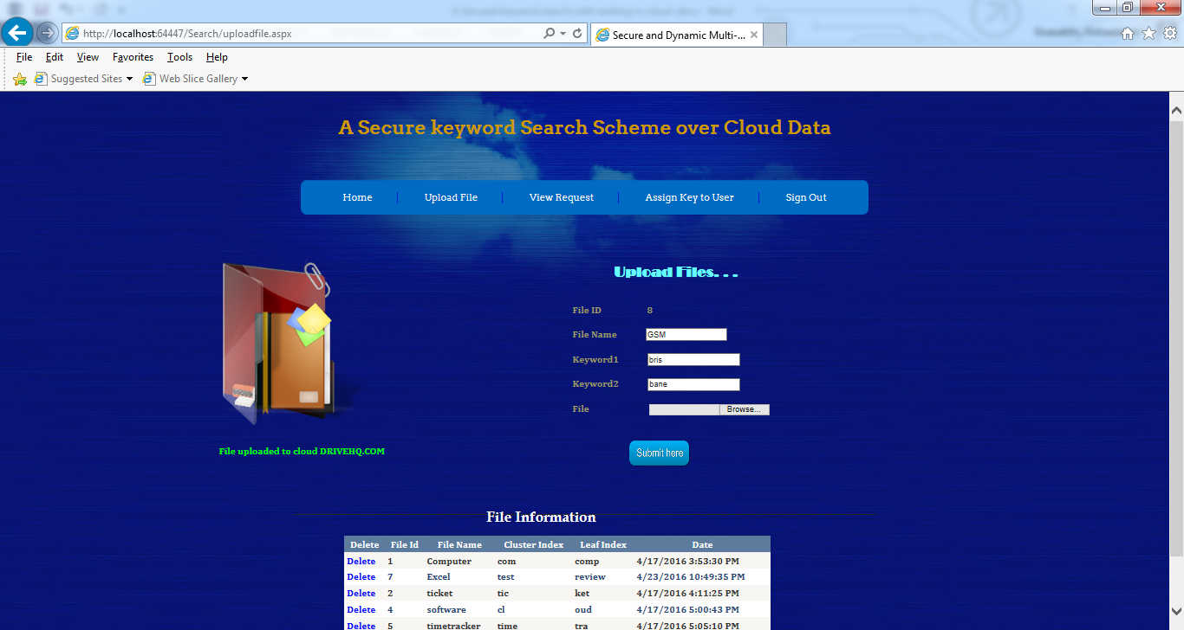

**User File Request:**

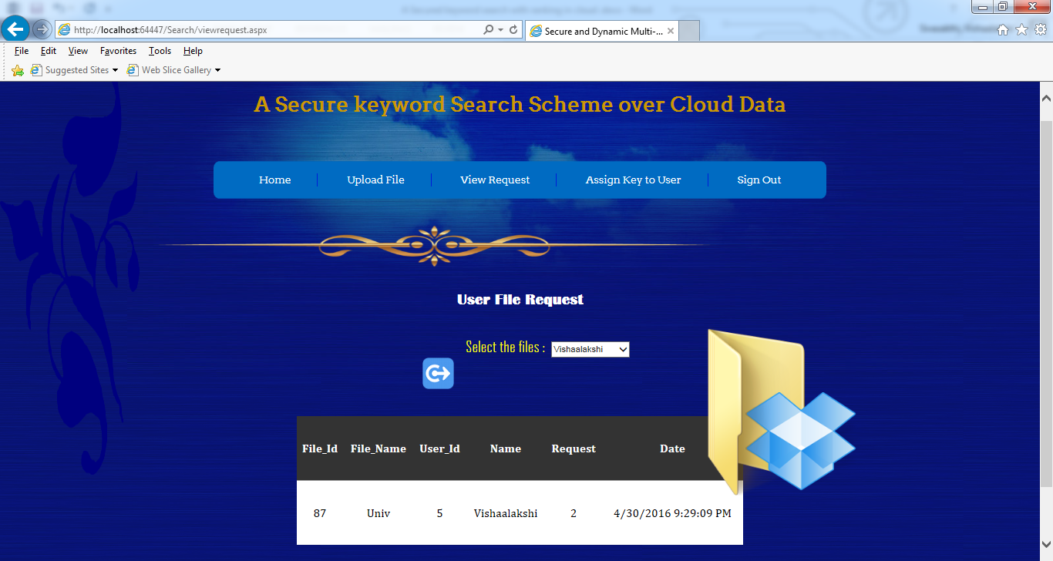

**Key Generation:**

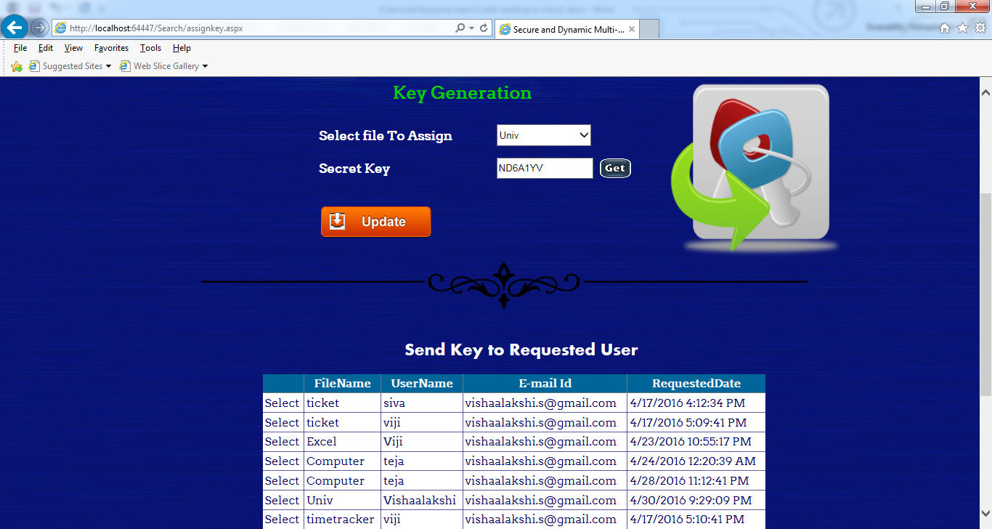

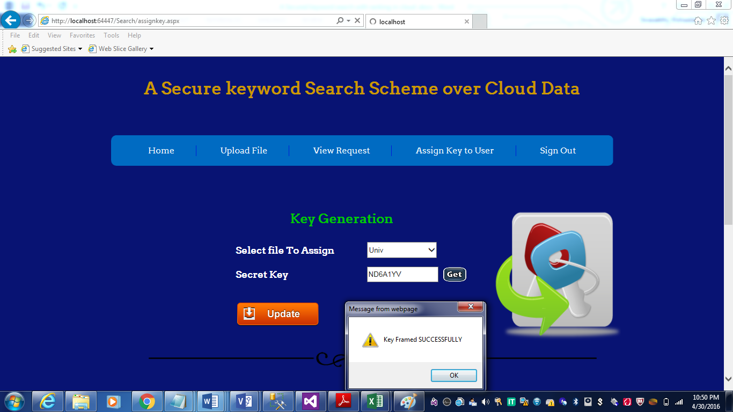

**Send Request:**

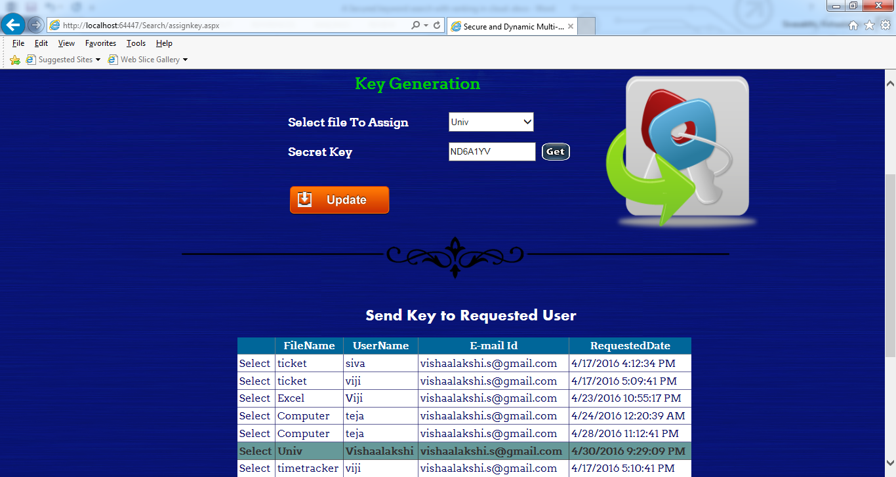



**CHAPTER 7**

**CONCLUSION, FUTURE ENHANCEMENT**

**7.1 Conclusion**

In this project, a secure, efficient and dynamic search scheme is proposed, which supports not only the accurate multi-keyword ranked search but also the dynamic deletion and insertion of documents. We construct a special keyword balanced binary tree as the index, and propose a Breadth Deepening Search algorithm to obtain better efficiency. The security of the scheme is protected against hacker’s user’s revocation using BIS key algorithm. Experimental results demonstrate the efficiency of our proposed scheme.

**7.2 Future Enhancement**

In future, the approach to compress the files to store in the cloud in order to reduce memory consumption in the cloud and faster download of the compressed files will be analyzed to handle memory challenges. Hence the performance of the search can be improved by avoiding repetition of search.

**APPENDIX**

**Source Code**

**Master Page:**

<%@ Master Language="C#" AutoEventWireup="true" CodeFile="MasterPage.master.cs" Inherits="MasterPage" %>

<!DOCTYPE html PUBLIC "-//W3C//DTD XHTML 1.0 Transitional//EN" "http://www.w3.org/TR/xhtml1/DTD/xhtml1-transitional.dtd">

<!--

Design by Free CSS Templates

http://www.freecsstemplates.org

Released for free under a Creative Commons Attribution 2.5 License

Name : SimpleDisplay

Description: A two-column, fixed-width design with dark color scheme.

Version : 1.0

Released : 20120611

->

<html xmlns="http://www.w3.org/1999/xhtml">

<head>

<meta name="keywords" content="" />

<meta name="description" content="" />

<meta http-equiv="content-type" content="text/html; charset=utf-8" />

<title>Secure and Dynamic Multi-keyword</title>

<link href="http://fonts.googleapis.com/css?family=Arvo" rel="stylesheet" type="text/css" />

<link href="style.css" rel="stylesheet" type="text/css" media="screen" />

<script type="text/javascript" src="jquery/jquery-1.4.2.min.js"></script>

<script type="text/javascript" src="jquery/jquery.gallerax-0.2.js"></script>

<style type="text/css">

@import "gallery.css";

</style>

</head>

<body>

<form id="form1" runat="server">

<div id="wrapper">

<div id="header">

<h1 style="font-size: xx-large" align="center">

&nbsp;</h1>

<h1 style="font-size: xx-large" align="center">

<a href="#" style="color: #CCCC00; font-weight: bold;"

>A Secure and Dynamic Multi-keyword Ranked SearchScheme over Encrypted Cloud Data</a> </h1>

<br />

<br />

<p style="font-size: xx-large">&nbsp;</p>

<h1 style="font-size: xx-large">&nbsp;&nbsp;&nbsp;&nbsp;&nbsp;</h1>

</div>

<!-- end #header -->

<br />

<br />

<br />

<br />

<div id="menu">

<ul>

<li class="current_page_item"><a href="home.aspx">Home</a></li>

<li><a href="signin.aspx">Data Owner</a></li>

<li><a href="signin.aspx">Cloud Server</a></li>

<li><a href="signin.aspx">Data User</a></li>

<%-- <li><a href="signin.aspx">Sign In</a></li>--%>

<li class="last"><a href="#">Contact</a></li>

</ul>

</div>

<div id="two-columns">

<div id="col1">

<h2>Secure and Dynamic Multi-keyword</h2>

<p align="justify">&nbsp;&nbsp;&nbsp;&nbsp;&nbsp;&nbsp;&nbsp;&nbsp;&nbsp;&nbsp;&nbsp;&nbsp;&nbsp;&nbsp;&nbsp; Due to the increasing popularity of cloud computing, more and more data owners are motivated to outsource their data

to cloud servers for great convenience and reduced cost in data management. However, sensitive data should be encrypted before

outsourcing for privacy requirements, which obsoletes data utilization like keyword-based document retrieval. A secure multi-keyword ranked search scheme over encrypted cloud data, which simultaneously supports dynamic update operations

like deletion and insertion of documents.<br />

</p>

<p><a href="#" class="link-style2">Encrypted Cloud Data</a></p>

</div>

<div id="col2">

&nbsp;<img src="images/cloud_storage-home.png" /></div>

<asp:ContentPlaceHolder id="ContentPlaceHolder1" runat="server">

</asp:ContentPlaceHolder>

</div>

<!-- end #menu -->

<!-- end #page -->

</div>

<div id="footer">

<p>Copyright @ 2016 SRM UNIVERSITY</p>

</div>

<!-- end #footer -->

</form>

</body>

</html>

**Home Page:**

<%@ Page Title="" Language="C#" MasterPageFile="~/MasterPage.master" AutoEventWireup="true" CodeFile="home.aspx.cs" Inherits="Default2" %>

<asp:Content ID="Content1" ContentPlaceHolderID="ContentPlaceHolder1" Runat="Server">

</asp:Content>

**Sign-In Page:**

using System;

using System.Configuration;

using System.Data;

using System.Linq;

using System.Web;

using System.Web.Security;

using System.Web.UI;

using System.Web.UI.HtmlControls;

using System.Web.UI.WebControls;

using System.Web.UI.WebControls.WebParts;

using System.Xml.Linq;

using System.Data.SqlClient;

public partial class Default2 : System.Web.UI.Page

{

SqlConnection con = new SqlConnection(ConfigurationManager.AppSettings["connection"]);

int count=0, uid;

string username;

protected void Page_Load(object sender, EventArgs e)

{

}

protected void Button1_Click(object sender, EventArgs e)

{

DropDownList1.Text="";

txt_unam.Text = "";

txt_pass.Text = "";

}

protected void btnlogin_Click1(object sender, EventArgs e)

{

if (DropDownList1.SelectedItem.Text == "Admin")

{

if (txt_unam.Text == "owner" && txt_pass.Text == "owner")

{

Response.Redirect("uploadfile.aspx");

}

else

MsgBox.Show("Invalid User");

}

else if (DropDownList1.SelectedItem.Text == "User")

{

con.Open();

string s1 = "select * from registration where username='" + txt_unam.Text + "' and password='" + txt_pass.Text + "'";

SqlCommand cmd = new SqlCommand(s1, con);

SqlDataReader read = cmd.ExecuteReader();

while (read.Read())

{

count++;

uid = Convert.ToInt32(read.GetValue(0).ToString());

username = read.GetValue(4).ToString();

}

read.Close();

if (count == 1)

{

Session["uid"] = uid;

Session["username"] = username;

Response.Redirect("userdetails.aspx");

}

else

{

MsgBox.Show("Incorrect UserName (Or) Password");

}

con.Close();

}

else if (DropDownList1.SelectedItem.Text == "Cloud")

{

if (txt_unam.Text == "cloud" && txt_pass.Text == "cloud")

{

Response.Redirect("home.aspx");

}

else

MsgBox.Show("Invalid User");

}

}

}

**Upload File:**

using System;

using System.Collections;

using System.Configuration;

using System.Data;

using System.Linq;

using System.Web;

using System.Web.Security;

using System.Web.UI;

using System.Web.UI.HtmlControls;

using System.Web.UI.WebControls;

using System.Web.UI.WebControls.WebParts;

using System.Xml.Linq;

using System.Data.SqlClient;

public partial class Default2 : System.Web.UI.Page

{

SqlConnection con = new SqlConnection(ConfigurationManager.AppSettings["connection"]);

Class1 cid = new Class1();

SqlDataAdapter da;

DataSet ds;

protected void Page_Load(object sender, EventArgs e)

{

Label8.Text = Convert.ToString(cid.createid2());

if (con.State == ConnectionState.Closed)

{

con.Open();

}

if (Page.IsPostBack != true)

{

Getcustomers();

}

}

private void Getcustomers()

{

da = new SqlDataAdapter("select fileid,fname,key1,key2,fdatetime from uploadfiles", con);

ds = new DataSet();

da.Fill(ds, "uploadfiles");

GridView1.DataSource = ds.Tables["uploadfiles"].DefaultView;

GridView1.DataBind();

}

protected void Button1_Click(object sender, EventArgs e)

{

if (FileUpload1.PostedFile == null || String.IsNullOrEmpty(FileUpload1.PostedFile.FileName) || FileUpload1.PostedFile.InputStream == null || TextBox2.Text == "")

{

lbl_msg.Text = "<br />Error - unable to upload file. Please try again.<br />";

}

else

{

SqlDataAdapter sda = new SqlDataAdapter("select * from uploadfiles where fname='" + TextBox2.Text + "' ", con);

DataSet ds = new DataSet();

sda.Fill(ds);

if (ds.Tables[0].Rows.Count > 0)

{

Session["fname"] = ds.Tables[0].Rows[0]["fname"].ToString();

lbl_msg.Text = "Redundancy Occur";

}

else

{

byte[] filebytes = new byte[FileUpload1.PostedFile.InputStream.Length + 1];

FileUpload1.PostedFile.InputStream.Read(filebytes, 0, filebytes.Length);

cid.uploadfile(Label8.Text, TextBox2.Text, TextBox3.Text, TextBox4.Text, filebytes);

// Label7.Visible = true;

lbl_msg.Text = "File successfully uploaded";

}

}

}

protected void GridView1_RowDeleting(object sender, GridViewDeleteEventArgs e)

{

Label fileid = new Label();

fileid = (Label)GridView1.Rows[e.RowIndex].Cells[1].FindControl("fileid");

if (fileid.Text != "")

{

da = new SqlDataAdapter("delete from uploadfiles where fileid=" + Convert.ToInt32(fileid.Text) + " ", con);

int res = da.SelectCommand.ExecuteNonQuery();

if (res == 1)

{

Getcustomers();

}

}

}

protected void GridView1_SelectedIndexChanged(object sender, EventArgs e)

{

}

}

**User Home Page:**

<%@ Page Title="" Language="C#" MasterPageFile="~/UserMasterPage.master" AutoEventWireup="true" CodeFile="userdetails.aspx.cs" Inherits="_Default" %>

<asp:Content ID="Content1" ContentPlaceHolderID="ContentPlaceHolder1" Runat="Server">

<p align="center">

&nbsp;&nbsp;&nbsp;

<img src="images/cloud.png" style="height: 244px; width: 528px" /></p>

<p align="justify">

Due to the increasing popularity of cloud computing, more and more data owners

are motivated to outsource their data to cloud servers for great convenience and

reduced cost in data management. However, sensitive data should be encrypted

before outsourcing for privacy requirements, which obsoletes data utilization

like keyword-based document retrieval. A secure multi-keyword ranked search

scheme over encrypted cloud data, which simultaneously supports dynamic update

operations like deletion and insertion of documents.</p>

</asp:Content>

**SEARCH FILE:**

using System;

using System.Collections;

using System.Configuration;

using System.Data;

using System.Linq;

using System.Web;

using System.Web.Security;

using System.Web.UI;

using System.Web.UI.HtmlControls;

using System.Web.UI.WebControls;

using System.Web.UI.WebControls.WebParts;

using System.Xml.Linq;

using System.Text.RegularExpressions;

using System.IO;

using System.Text;

using System.Security.Cryptography;

using System.Data.SqlClient;

public partial class Default2 : System.Web.UI.Page

{

int h = 0;

Class1 obj = new Class1();

public static RSACryptoServiceProvider rsa;

StringBuilder sb = new StringBuilder();

StringBuilder sb1 = new StringBuilder();

protected void Page_Load(object sender, EventArgs e)

{

//Label4.Text = (string)Session["uid"];

Label5.Text = (string)Session["name"];

if (!IsPostBack)

{

//Panel1.Visible = false;

//Panel2.Visible = false;

Label1.Visible = false;

//Label2.Visible = false;

//TextBox1.Visible = false;

}

Session["data"] = TextBox1.Text;

string text = TextBox1.Text;

string splitby = " ";

Regex rg = new Regex(splitby);

string[] st = rg.Split(text);

int m = st.Count();

for (int k = 0; k < m; k++)

{

if (st[k].ToString() != "")

{

DataSet da = new DataSet();

da = obj.filematching(st[k].ToString());

if (da.Tables[0].Rows.Count > 0)

{

for (int f = 0; f < da.Tables[0].Rows.Count; f++)

{

// creation of linkbutton

LinkButton linkbutton = new LinkButton();

linkbutton.Text = da.Tables[0].Rows[f]["fname"].ToString() + "<br><br>";

linkbutton.Visible = true;

linkbutton.CommandName = da.Tables[0].Rows[f]["fname"].ToString();

linkbutton.Command += new CommandEventHandler(this.link_click);

linkbutton.ID = h.ToString();

this.downloadfiles.Controls.Add(linkbutton);

linkbutton.Visible = true;

Label3.Visible = true;

Panel4.Visible = true;

Panel6.Visible = true;

h++;

}

}

else

{

//MsgBox.Show("No files found");

if (st[k].ToString() != "")

{

//DataSet da = new DataSet();

da = obj.filematching1(st[k].ToString());

if (da.Tables[0].Rows.Count > 0)

{

for (int f = 0; f < da.Tables[0].Rows.Count; f++)

{

// creation of linkbutton

LinkButton linkbutton = new LinkButton();

linkbutton.Text = da.Tables[0].Rows[f]["key1"].ToString() + "<br><br>";

linkbutton.Visible = true;

linkbutton.CommandName = da.Tables[0].Rows[f]["key1"].ToString();

linkbutton.Command += new CommandEventHandler(this.link_click);

linkbutton.ID = h.ToString();

this.downloadfiles.Controls.Add(linkbutton);

linkbutton.Visible = true;

Label3.Visible = true;

Panel4.Visible = true;

Panel6.Visible = true;

h++;

}

}

else

{

//MsgBox.Show("No files found");

}

}

}

}

}

}

protected void Button1_Click(object sender, EventArgs e)

{

try

{

lblMsg.Text = "";

if (RadioButton1.Checked == true)

{

SqlConnection con = new SqlConnection(ConfigurationManager.AppSettings["connection"]);

try

{

SqlDataAdapter da = new SqlDataAdapter("select * from uploadfiles where fname='" + TextBox1.Text + "'", con);

DataSet ds = new DataSet();

da.Fill(ds);

if (ds.Tables[0].Rows.Count <= 0)

{

lblMsg.Visible = true;

lblMsg.Text = "NO FILE NAME AVAILABLE!";

}

//Panel1.Visible = true;

Panel2.Visible = true;

Session["message"] = TextBox1.Text;

// create secret key

AssignParameter();

//provide public and private RSA params

StreamWriter writer = new StreamWriter(@"C:\Users\SYSTEM4\Documents\Visual Studio 2010\WebSites\WebSite4\privatekey.xml");

string publicPrivateKeyXML = rsa.ToXmlString(true);

writer.Write(publicPrivateKeyXML);

writer.Close();

//provide public only RSA params

writer = new StreamWriter(@"C:\Users\SYSTEM4\Documents\Visual Studio 2010\WebSites\WebSite4\publickey.xml");

string publicOnlyKeyXML1 = rsa.ToXmlString(false);

writer.Write(publicOnlyKeyXML1);

writer.Close();

// Label1.Text=Cryptography.EncryptData(txt_keyword.Text);

// Encryption

AssignParameter();

StreamReader reader = new StreamReader(@"C:\Users\SYSTEM4\Documents\Visual Studio 2010\WebSites\WebSite4\publickey.xml");

string publicOnlyKeyXML = reader.ReadToEnd();

rsa.FromXmlString(publicOnlyKeyXML);

reader.Close();

//read plaintext, encrypt it to ciphertext

byte[] plainbytes = System.Text.Encoding.UTF8.GetBytes(TextBox1.Text);

byte[] cipherbytes = rsa.Encrypt(plainbytes, false);

for (int x = 0; x < cipherbytes.Length; x++)

{

sb.Append(cipherbytes[x].ToString() + "<br>");

}

Label1.Text = Convert.ToBase64String(cipherbytes);

sb.Append(Label1.Text);

Literal1.Text = Convert.ToString(sb);

AssignParameter();

byte[] getpassword = Convert.FromBase64String(Label1.Text);

StreamReader reader1 = new StreamReader(@"C:\Users\SYSTEM4\Documents\Visual Studio 2010\WebSites\WebSite4\privatekey.xml");

string publicPrivateKeyXML2 = reader1.ReadToEnd();

rsa.FromXmlString(publicPrivateKeyXML2);

reader1.Close();

byte[] plain = rsa.Decrypt(getpassword, false);

for (int y = 0; y < plain.Length; y++)

{

sb1.Append(plain[y].ToString() + "<br>");

}

Label2.Text = System.Text.Encoding.UTF8.GetString(plain);

sb1.Append(Label2.Text);

Literal2.Text = Convert.ToString(sb1);

//obj.storesearchdatas((string)Session["userid"],Label1.Text, Label2.Text);

}

catch (Exception ex)

{

lblMsg.Visible = true;

lblMsg.Text = "Error --> " + ex.Message;

}

finally

{

con.Close();

}

}

else if (RadioButton2.Checked == true)

{

SqlConnection con = new SqlConnection(ConfigurationManager.AppSettings["connection"]);

try

{

SqlDataAdapter da = new SqlDataAdapter("select * from uploadfiles where key1='" + TextBox1.Text + "' ", con);

DataSet ds = new DataSet();

da.Fill(ds);

if (ds.Tables[0].Rows.Count <= 0)

{

lblMsg.Visible = true;

lblMsg.Text = "NO KEYWORD ARE AVAILABLE!";

}

//Panel1.Visible = true;

Panel2.Visible = true;

Session["message"] = TextBox1.Text;

// create secret key

AssignParameter();

//provide public and private RSA params

StreamWriter writer = new StreamWriter(@"C:\Users\SYSTEM4\Documents\Visual Studio 2010\WebSites\WebSite4\privatekey.xml");

string publicPrivateKeyXML = rsa.ToXmlString(true);

writer.Write(publicPrivateKeyXML);

writer.Close();

//provide public only RSA params

writer = new StreamWriter(@"C:\Users\SYSTEM4\Documents\Visual Studio 2010\WebSites\WebSite4\publickey.xml");

string publicOnlyKeyXML1 = rsa.ToXmlString(false);

writer.Write(publicOnlyKeyXML1);

writer.Close();

// Label1.Text=Cryptography.EncryptData(txt_keyword.Text);

// Encryption

AssignParameter();

StreamReader reader = new StreamReader(@"C:\Users\SYSTEM4\Documents\Visual Studio 2010\WebSites\WebSite4\publickey.xml");

string publicOnlyKeyXML = reader.ReadToEnd();

rsa.FromXmlString(publicOnlyKeyXML);

reader.Close();

//read plaintext, encrypt it to ciphertext

byte[] plainbytes = System.Text.Encoding.UTF8.GetBytes(TextBox1.Text);

byte[] cipherbytes = rsa.Encrypt(plainbytes, false);

for (int x = 0; x < cipherbytes.Length; x++)

{

sb.Append(cipherbytes[x].ToString() + "<br>");

}

Label1.Text = Convert.ToBase64String(cipherbytes);

sb.Append(Label1.Text);

Literal1.Text = Convert.ToString(sb);

AssignParameter();

byte[] getpassword = Convert.FromBase64String(Label1.Text);

StreamReader reader1 = new StreamReader(@"C:\Users\SYSTEM4\Documents\Visual Studio 2010\WebSites\WebSite4\privatekey.xml");

string publicPrivateKeyXML2 = reader1.ReadToEnd();

rsa.FromXmlString(publicPrivateKeyXML2);

reader1.Close();

byte[] plain = rsa.Decrypt(getpassword, false);

for (int y = 0; y < plain.Length; y++)

{

sb1.Append(plain[y].ToString() + "<br>");

}

Label2.Text = System.Text.Encoding.UTF8.GetString(plain);

sb1.Append(Label2.Text);

Literal2.Text = Convert.ToString(sb1);

//obj.storesearchdatas((string)Session["userid"],Label1.Text, Label2.Text);

}

catch (Exception ex)

{

lblMsg.Visible = true;

lblMsg.Text = "Error --> " + ex.Message;

}

finally

{

con.Close();

}

}

}

catch (Exception ex)

{

MsgBox.Show(ex.Message);

}

}

public static void AssignParameter()

{

const int PROVIDER_RSA_FULL = 1;

const string CONTAINER_NAME = "SpiderContainer1";

CspParameters cspParams;

cspParams = new CspParameters(PROVIDER_RSA_FULL);

cspParams.KeyContainerName = CONTAINER_NAME;

cspParams.Flags = CspProviderFlags.UseMachineKeyStore;

cspParams.ProviderName = "Microsoft Strong Cryptographic Provider";

rsa = new RSACryptoServiceProvider(cspParams);

}

protected void link_click(object sender, CommandEventArgs e)

{

//Response.Write(" <script type='text/javascript'> finaldoc=window.open('Default.aspx?id='"+e.CommandName+"'');</script>");

Response.Redirect("downloadfiles1.aspx?id='" + e.CommandName + "'");

}

protected void RadioButton2_CheckedChanged(object sender, EventArgs e)

{

}

}

**REFERENCES**

1. B. Wang, S. Yu, W. Lou, and Y. T. Hou, “*Privacy-preserving multi-keyword fuzzy search over encrypted data in the cloud*,” in IEEE INFOCOM, 2014.
2. C. Orencik, M. Kantarcioglu, and E. Savas, “*A practical and secure multi-keyword search method over encrypted cloud data,*” in Cloud Computing (CLOUD), 2013 IEEE Sixth International Conference on. IEEE, 2013, pp. 390–397.
3. C. Wang, K. Ren, S. Yu, and K. M. R. Urs, “*Achieving usable and privacy-assured similarity search over outsourced cloud data*,” in INFOCOM, 2012 Proceedings IEEE. IEEE, 2012, pp. 451–459.
4. D. Cash, S. Jarecki, C. Jutla, H. Krawczyk, M.-C. Ros¸u, and M. Steiner, “*Highly-scalable searchable symmetric encryption with support for boolean queries*,” in Advances in Cryptology– CRYPTO 2013. Springer, 2013, pp. 353–373.
5. D. Cash, J. Jaeger, S. Jarecki, C. Jutla, H. Krawczyk, M.-C. Rosu, and M. Stein *“Dynamic searchable encryption in very large databases: Data structures and implementation,”* in Proc. of NDSS, vol. 14, 2014.
6. E.-J. Goh et al., “*Secure indexes*.” IACR Cryptology ePrint Archive, vol. 2003, p. 216, 2003.
7. L. Ballard, S. Kamara, and F. Monrose, “*Achieving efficient conjunctive keyword searches over encrypted data*,” in Proceedings of the 7th international conference on Information and Communications Security. Springer-Verlag, 2005, pp. 414–426.
8. M. Kuzu, M. S. Islam, and M. Kantarcioglu, “*Efficient similarity search over encrypted data*,” in Data Engineering (ICDE), 2012 IEEE 28th International Conference on. IEEE, 2012, pp. 1156–1167.
9. P. Golle, J. Staddon, and B. Waters, “*Secure conjunctive keyword search over encrypted data”* in Applied Cryptography and Network Security. Springer, 2004, pp. 31–45.
10. S. Kamara and C. Papamanthou, “*Parallel and dynamic searchable symmetric encryption, in Financial Cryptography and Data Security*” Springer, 2013, pp. 258–274.
11. Y.-C. Chang and M. Mitzenmacher, “*Privacy preserving keyword searches on remotely encrypted data,*” in Proceedings of the Third international conference on Applied Cryptography and Network Security. Springer-Verlag, 2005, pp. 442–455.
12. Y. H. Hwang and P. J. Lee, “*Public key encryption with conjunctive keyword search and its extension to a multi-user system*,” in Proceedings of the First international conference on Pairing-Based Cryptography. Springer-Verlag, 2007, pp. 2–22.
13. Zhihua Xia, Member, IEEE, Xinhui Wang, Xingming Sun, Senior Member, IEEE,

and Qian Wang, Member, IEEE,”*A Secure and Dynamic Multi-keyword Ranked Search Scheme over Encrypted Cloud Data”*